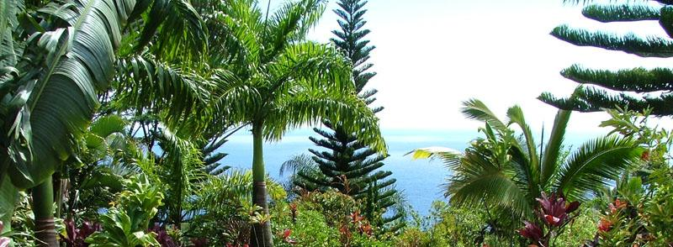

Hawai'i also struggles with the many invasive species like the Coqui which was brought accidently from Puerto Rico to the Big Island, are literally driving many residents out of their minds. Their population increased noticeably with no Mongoose, their predator to eat their eggs.



The best thing about Hawai'i's weather is that it is bipolar. You may be driving along the island and be in a rain storm one minute and in bright sun the next. Hence, you cannot separate the seasons, summer and winter assuming there is a wet and a dry season. It has good weather and bad weather throughout the year. One of the best moments is when the island are washed with the cool breeze of the trade mark winds that blow north-east to east-north-east. However, every good side also has a bad side; when these winds die down and practically reverse so that a south wind blows over the islands, resulting in very hot and muggy conditions. These winds are called Kona winds.





Hawaii Island contains 11 of the world’s 13 defined eco zones; so I’m not trying to force you to go on an Eco Tour in Hawaii, but I am proving it. The Biome location of our destination is Tropical Rainforest. Hawaii is very rich is bio-diversity. Its common flora and fauna are seabirds, fish, marine mammals, and in the drier areas: mongooses, rats, frogs, toads; in the more remote regions of some of the islands, deer, sheep, pigs, donkeys, and goats. Also, the insect population is multitudinous, and marine life abounds in Hawaiian waters.

*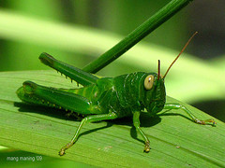*

The abiotic resources of Hawaii’s ecosystem are unbelievably beautiful. It’s famous for its sun-drenched beaches, misty rainbow-filled valleys, pristine waterfalls, cool highlands, and lush mountains. The Hawaiian Islands are home to some of the world's most beautiful waterfalls, luxurious gardens, gorgeous arboretums, and vibrant landscapes.

**

In every beautiful story there is a villain; endangered species and alien species always cause an unbearable threat to the life on earth. The ‘Akiapola au’, a rare bird found on the Big Island of Hawai'i is just one example of a species that is fading fast. Most experts predict that their numbers have dwindled to between 1,000-1,500. Fortunately, an ‘Akiapola au’ was discovered in 2006, so perhaps hope still remains for this incredible bird.

The best thing about Hawai'i's weather is that it is bipolar. You may be driving along the island and be in a rain storm one minute and in bright sun the next. Hence, you cannot separate the seasons, summer and winter assuming there is a wet and a dry season. It has good weather and bad weather throughout the year. One of the best moments is when the island are washed with the cool breeze of the trade mark winds that blow north-east to east-north-east. However, every good side also has a bad side; when these winds die down and practically reverse so that a south wind blows over the islands, resulting in very hot and muggy conditions. These winds are called Kona winds. Hawaii has a pleasant temperature throughout the year; the average high and low in the summer are around 85 and 71 respectively, while the average high and low in the winter are 78 and 62 respectively.



The actual travel differs from the theory or our plan, but why? Life is never perfect; we cannot always go 100% according to the plan. There will always be some halts and disturbances hence, the plan may not be the exact outcome. One might miss a plane, or take the wrong plane, or find another route that is longer but cheaper, or happen to post phone the trip. Any of these reasons may cause your travel time to differ to a faster average speed or a slower average speed from what’s on the plan.